1. Write shell script using for loop to print the following patterns on screen

**CODE:**

#!/bin/bash

for i in {1..5}

do

for j in $(seq 1 $i)

do

printf "$j "

done

echo

done

**OUTUT:**

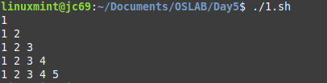

1. Write shell script using for loop to print the following patterns on screen

**CODE:**

#!/bin/bash

for i in {1..9}

do

for((k=1; k <=$((9 - $i));k++))

do

echo -n " "

done

for((j=1;j<=$i;j++))

do

echo -n "$i "

done

echo " "

done

**OUTPUT:**

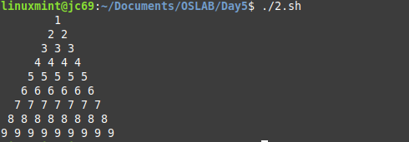

3.Write Shell Script to find factorial of a number

**CODE:**

#!/bin/bash

myfact(){

if [[ $1 -le 1 ]]

then echo 1

else echo $(( $1 * $(myfact $(($1 - 1)))))

fi

}

myfact $1

**OUTPUT:**



1. Write Shell Script to Display numbers Using Array

**CODE:**

#!/bin/bash

arr=( "$@" )

echo We are creating array using command line arguments

printf "Array elements are : "

echo ${arr[@]}

**OUTPUT:**



1. Write Script to add two numbers using function

**CODE:**

#!/bin/bash

add(){

echo $(( $1 + $2 ))

}

printf "Sum is : "

add $1 $2

**OUTPUT:**



1. Write Shell Script for Bubble Sort

**CODE:**

#!/bin/bash

arr=( "$@" )

echo We will take array elements as command line arguments

printf "Array in original order : "

echo ${arr[*]}

for((i=0; i < $# ;i++))

do

for((j=0; j < $# - 1;j++))

do

if [ ${arr[j]} -gt ${arr[$((j+1))]} ]

then

temp=${arr[j]}

arr[$j]=${arr[$((j+1))]}

arr[$((j+1))]=$temp

fi

done

done

printf "Array in sorted order : "

echo ${arr[*]}

**OUTPUT:**

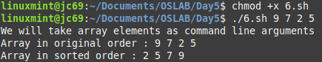

1. Write Shell Script to swap two numbers without using third variable

**CODE:**

#!/bin/bash

printf "Enter first number : "

read a

printf "Enter second number : "

read b

echo "a before swapping is $a and b is $b"

#swapping

a=$((a+b))

b=$((a - b))

a=$((a-b))

echo "a after swapping is $a and b is $b"

**OUTPUT:**

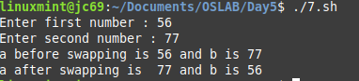

1. Write Shell Script to Sort Number in Descending Order

**CODE:**

#!/bin/bash

arr=( "$@" )

echo We will take array elements as command line arguments

printf "Array in original order : "

echo ${arr[*]}

for((i=0; i < $# ;i++))

do

for((j=0; j < $# - 1;j++))

do

if [ ${arr[j]} -lt ${arr[$((j+1))]} ]

then

temp=${arr[j]}

arr[$j]=${arr[$((j+1))]}

arr[$((j+1))]=$temp

fi

done

done

printf "Array in reverse sorted order : "

echo ${arr[*]}

**OUTPUT:**

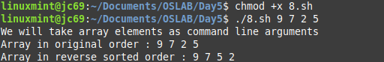

1. Write shell script for Insertion Sort

**CODE:**

#!/bin/bash

arr=( "$@" )

echo "Original array elements are : " "${arr[*]}"

j=1

while [ $j -lt "$#" ]

do

c=0

k=$(expr $j - 1)

while [ $k -ge 0 ]

do

if [ ${arr[k]} -gt ${arr[j]} ]

then

c=$(expr $c + 1)

fi

k=$(expr $k - 1)

done

x=$j

y=$(expr $j - 1)

while [ $c -gt 0 ]

do

# Swapping the elements

temp=${arr[x]}

arr[$x]=${arr[y]}

arr[$y]=$temp

x=$(expr $x - 1)

y=$(expr $y - 1)

c=$(expr $c - 1)

done

j=$(expr $j + 1)

done

printf "Sorted array using insertion sort is : "

echo "${arr[*]}"

**OUTPUT:**



1. Write Shell Script to Print Fibonacci Series

**CODE:**

#!/bin/bash

N=$1

a=0

b=1

printf "The Fibonacci series is : "

for (( i=0; i<N; i++ ))

do

printf "$a "

fn=$((a + b))

a=$b

b=$fn

done

echo

**OUTPUT:**



1. Write Shell Script to reverse a String

**CODE:**

#!/bin/bash

printf "Enter string : "

read str

revstr=`echo $str | rev`

echo "Original String : $str"

echo "Reversed String : $revstr"

**OUTPUT:**

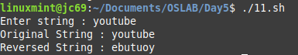

1. Write Shell Script to find "a" to the power "b" using function

**CODE:**

#!/bin/bash

#function to find "a" to the power "b"

power()

{

num=$1

pow=$2

counter=1

result=1

if((pow==0)); then

result=1

fi

if ((num==0)); then

result=0

fi

if((num>=1&&pow>=1)); then

while((counter<=pow))

do

result=$((result*num))

counter=$((counter + 1))

done

fi

#Printing the result

echo "$1 to the power $2 is $result"

}

#main script

read -p "Enter number:" num

read -p "Enter power:" pow

#calling above function

power $num $pow

**OUTPUT:**

